<!DOCTYPE html>

<html>

<style>

table, th, td {

border:1px solid black;

border-collapse: collapse;

}

</style>

<body>

<h2>100% wide HTML Table</h2>

<table style="width:100%">

<tr>

<th>Firstname</th>

<th>Lastname</th>

<th>Age</th>

</tr>

<tr>

<td>Jill</td>

<td>Smith</td>

<td>50</td>

</tr>

<tr>

<td>Eve</td>

<td>Jackson</td>

<td>94</td>

</tr>

<tr>

<td>John</td>

<td>Doe</td>

<td>80</td>

</tr>

</table>

</body>

</html>

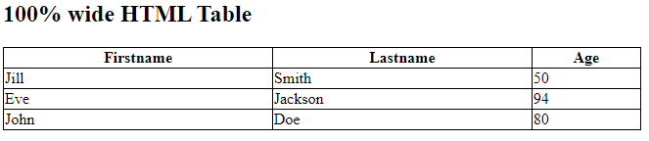

<!DOCTYPE html>

<html>

<style>

table, th, td {

border:1px solid black;

border-collapse: collapse;

}

</style>

<body>

<h2 align=center>Establecer la primera columna al 70% del ancho de la tabla</h2>

<table style="width:100%">

<tr>

<th style="width:70%">Nombre</th>

<th>Apellido</th>

<th>Edad</th>

</tr>

<tr>

<td>Jill</td>

<td>Smith</td>

<td align=right>50</td>

</tr>

<tr>

<td>Eve</td>

<td>Jackson</td>

<td align=right>94</td>

</tr>

<tr>

<td>John</td>

<td>Doe</td>

<td align=right>80</td>

</tr>

</table>

</body>

</html>

